# ANEXO I. INSTRUCCIONES DE ARMADO

A continuación, se presenta las instrucciones para el armado del brazo robótico utilizando el kit Lego Mindstorms EV3. Estas instrucciones fueron generadas por el software Lego Digital Designer. Se divide este ANEXO en cuatro partes: construcción de la base, primer eslabón, segundo eslabón y pinza robótica.

## Base del Brazo Robótico

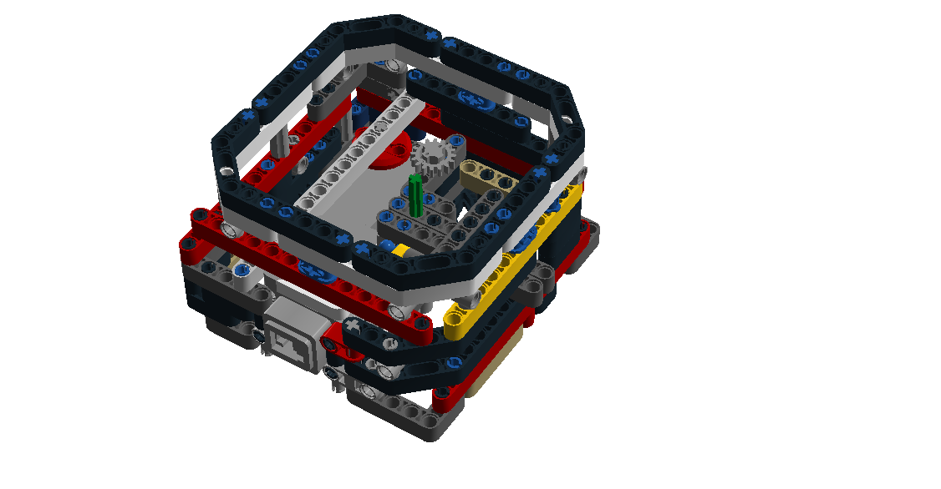

*Conexión con EV3*

*Eje de giro para el primer eslabón*

## 1er eslabón del brazo robótico

*Puertos para conexión de los motores*

*Conexión con el segundo eslabón*

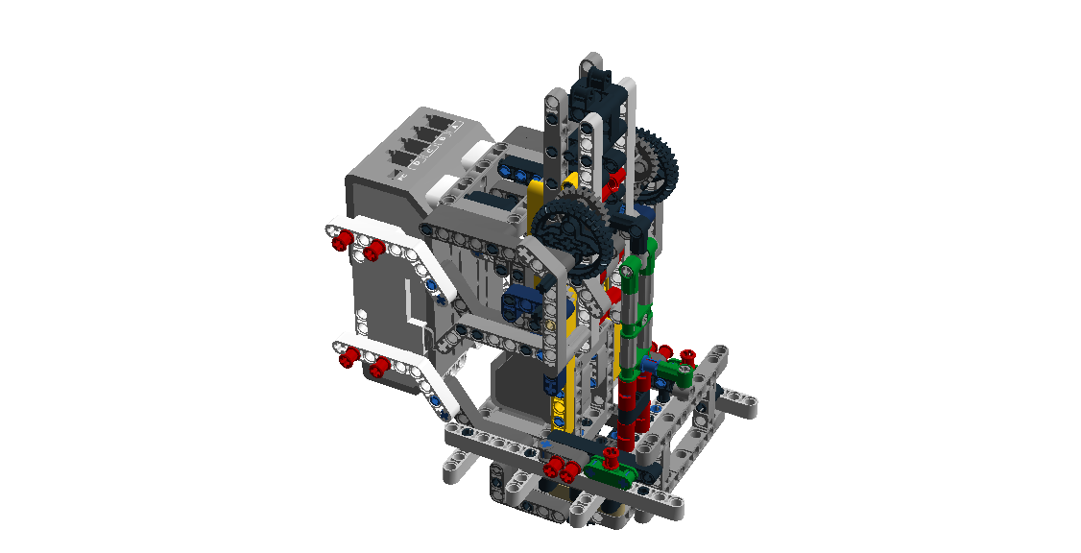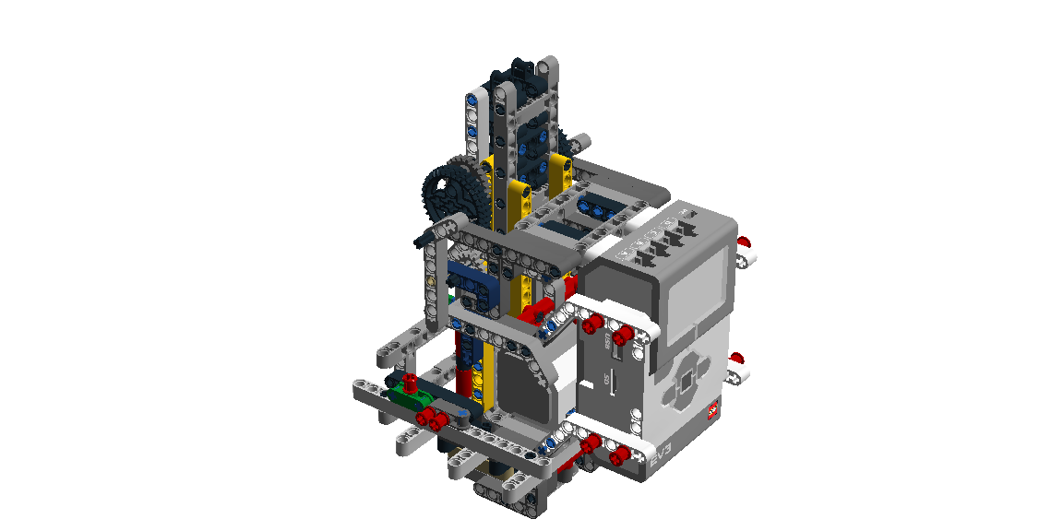

*Conexión con la base*

## 2do eslabón del brazo robótico

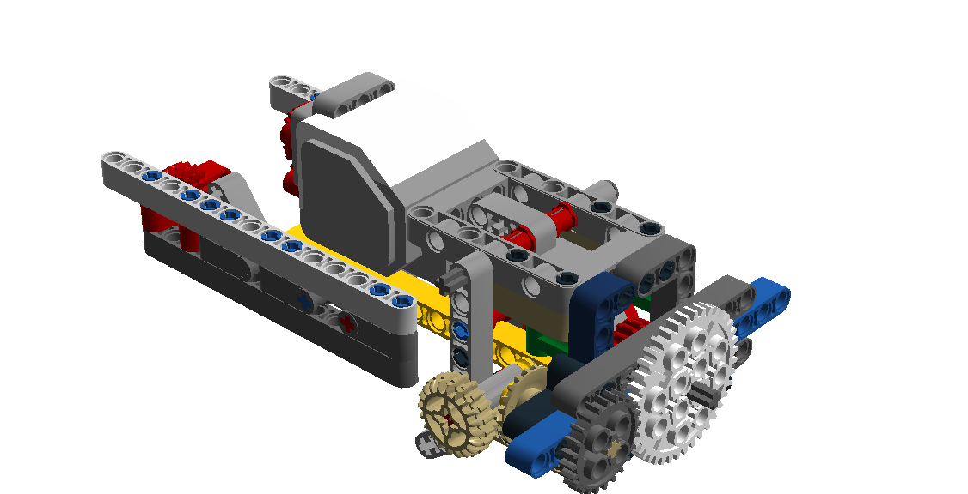

*Conexión con la pinza robótica*

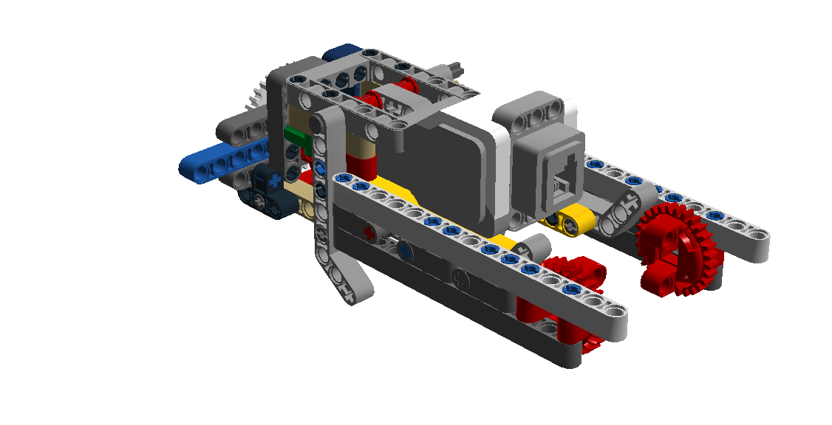

*Conexión con EV3*

*Conexión con el primer eslabón*

## Pinza

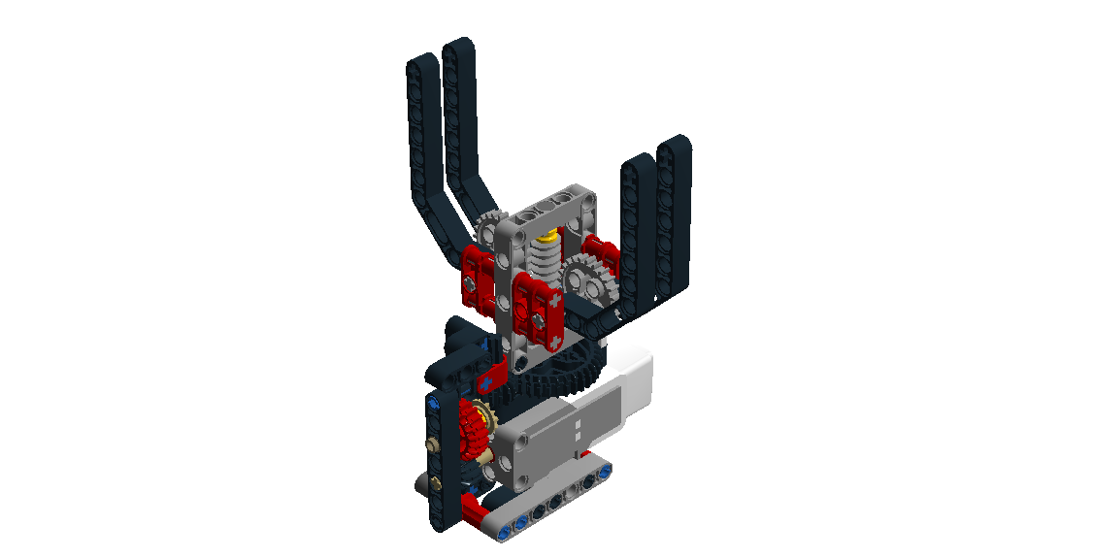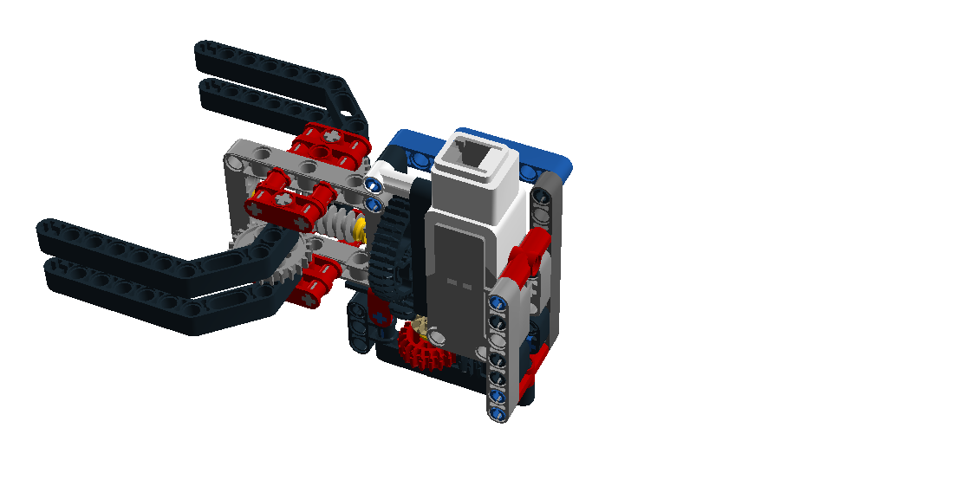

*Conexión con el segundo eslabón*

*Conexión con EV3*

## Brazo robótico de 3GDL: modelo Completo

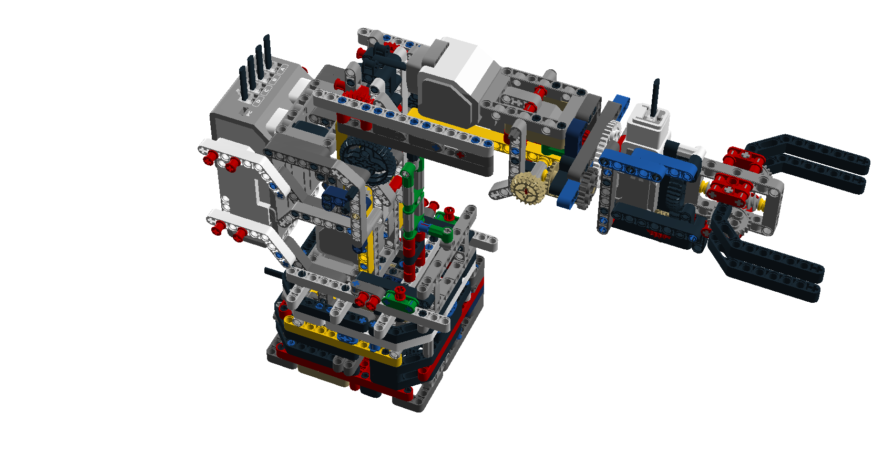

# Instrucciones de armado

Estas instrucciones fueron generadas por el software Lego Digital Designer.

## Primer eslabón del brazo robótico

|  |  |  |
| --- | --- | --- |
| 1x | C:\Users\z_tja\AppData\Local\Microsoft\Windows\INetCache\Content.Word\Brick1.png | C:\Users\z_tja\AppData\Local\Microsoft\Windows\INetCache\Content.Word\Step2.png |
| 1x | Brick3 |
| 1x | C:\Users\Sofia Zea\AppData\Local\Microsoft\Windows\INetCache\Content.Word\Brick4.png |
| 1x | C:\Users\Sofia Zea\AppData\Local\Microsoft\Windows\INetCache\Content.Word\Brick2.png |
| 1x | C:\Users\Sofia Zea\AppData\Local\Microsoft\Windows\INetCache\Content.Word\Brick4.png | C:\Users\Sofia Zea\AppData\Local\Microsoft\Windows\INetCache\Content.Word\Step4.png |
| 2x | Brick3 |
| 4x | Brick1 |
| 1x | C:\Users\Sofia Zea\AppData\Local\Microsoft\Windows\INetCache\Content.Word\Brick6.png |
| 1x | C:\Users\Sofia Zea\AppData\Local\Microsoft\Windows\INetCache\Content.Word\Brick2.png | **C:\Users\Sofia Zea\AppData\Local\Microsoft\Windows\INetCache\Content.Word\Step5.png** |
| 3x | Brick3 |
| 1x | Brick3 |
| 1x | C:\Users\Sofia Zea\AppData\Local\Microsoft\Windows\INetCache\Content.Word\Brick8.png |
| 1x | C:\Users\Sofia Zea\AppData\Local\Microsoft\Windows\INetCache\Content.Word\Step6.png | **C:\Users\Sofia Zea\AppData\Local\Microsoft\Windows\INetCache\Content.Word\Step8.png** |
| 1x | C:\Users\Sofia Zea\AppData\Local\Microsoft\Windows\INetCache\Content.Word\Brick9.png |
| 1x | C:\Users\Sofia Zea\AppData\Local\Microsoft\Windows\INetCache\Content.Word\Brick6.png | C:\Users\Sofia Zea\AppData\Local\Microsoft\Windows\INetCache\Content.Word\Step9.png |
| 1x | Brick3 |
| 1x | C:\Users\Sofia Zea\AppData\Local\Microsoft\Windows\INetCache\Content.Word\Brick10.png |
| 1x | C:\Users\Sofia Zea\AppData\Local\Microsoft\Windows\INetCache\Content.Word\Brick11.png |
| 1x | Brick3 | C:\Users\Sofia Zea\AppData\Local\Microsoft\Windows\INetCache\Content.Word\Step10.png |
| 1x | C:\Users\Sofia Zea\AppData\Local\Microsoft\Windows\INetCache\Content.Word\Brick12.png |
| 1x | Brick3 |
| 1x | C:\Users\Sofia Zea\AppData\Local\Microsoft\Windows\INetCache\Content.Word\Step11.png | C:\Users\Sofia Zea\AppData\Local\Microsoft\Windows\INetCache\Content.Word\Step16.png |
| 4x | Brick3 |
| 1x | Brick3 |
| 1x | C:\Users\Sofia Zea\AppData\Local\Microsoft\Windows\INetCache\Content.Word\Brick14.png | C:\Users\Sofia Zea\AppData\Local\Microsoft\Windows\INetCache\Content.Word\Step17.png |
| 2x | Brick3 |
| 1x | C:\Users\Sofia Zea\AppData\Local\Microsoft\Windows\INetCache\Content.Word\Brick15.png |
| 1x | C:\Users\Sofia Zea\AppData\Local\Microsoft\Windows\INetCache\Content.Word\Brick16.png | C:\Users\Sofia Zea\AppData\Local\Microsoft\Windows\INetCache\Content.Word\Step18.png |
| 1x | C:\Users\Sofia Zea\AppData\Local\Microsoft\Windows\INetCache\Content.Word\Brick9.png |
| 1x | Brick3 |
| 1x | C:\Users\Sofia Zea\AppData\Local\Microsoft\Windows\INetCache\Content.Word\Brick4.png |
| 1x | C:\Users\Sofia Zea\AppData\Local\Microsoft\Windows\INetCache\Content.Word\Brick14.png | C:\Users\Sofia Zea\AppData\Local\Microsoft\Windows\INetCache\Content.Word\Step19.png |
| 1x | C:\Users\Sofia Zea\AppData\Local\Microsoft\Windows\INetCache\Content.Word\Brick10.png |
| 1x | C:\Users\Sofia Zea\AppData\Local\Microsoft\Windows\INetCache\Content.Word\Brick17.png |
| 1x | C:\Users\Sofia Zea\AppData\Local\Microsoft\Windows\INetCache\Content.Word\Brick18.png |
| 1x | C:\Users\Sofia Zea\AppData\Local\Microsoft\Windows\INetCache\Content.Word\Step19.png | C:\Users\Sofia Zea\AppData\Local\Microsoft\Windows\INetCache\Content.Word\Step20.png |
| 1x | Brick3 | C:\Users\Sofia Zea\AppData\Local\Microsoft\Windows\INetCache\Content.Word\Step21.png |
| 2x | C:\Users\Sofia Zea\AppData\Local\Microsoft\Windows\INetCache\Content.Word\Brick5.png |
| 3x | Brick3 | C:\Users\Sofia Zea\AppData\Local\Microsoft\Windows\INetCache\Content.Word\Step22.png |
| 1x | C:\Users\Sofia Zea\AppData\Local\Microsoft\Windows\INetCache\Content.Word\Brick5.png |
| 1x | Brick3 |
| 2x | C:\Users\Sofia Zea\AppData\Local\Microsoft\Windows\INetCache\Content.Word\Brick0.png | C:\Users\Sofia Zea\AppData\Local\Microsoft\Windows\INetCache\Content.Word\Step25.png |
| 2x | C:\Users\Sofia Zea\AppData\Local\Microsoft\Windows\INetCache\Content.Word\Brick4.png |
| 2x | C:\Users\Sofia Zea\AppData\Local\Microsoft\Windows\INetCache\Content.Word\Brick1.png |
| 1x | C:\Users\Sofia Zea\AppData\Local\Microsoft\Windows\INetCache\Content.Word\Brick6.png | C:\Users\Sofia Zea\AppData\Local\Microsoft\Windows\INetCache\Content.Word\Step26.png |
| 1x | C:\Users\Sofia Zea\AppData\Local\Microsoft\Windows\INetCache\Content.Word\Brick3.png |
| 2x | C:\Users\Sofia Zea\AppData\Local\Microsoft\Windows\INetCache\Content.Word\Brick5.png |
| 1x | C:\Users\Sofia Zea\AppData\Local\Microsoft\Windows\INetCache\Content.Word\Brick2.png | C:\Users\Sofia Zea\AppData\Local\Microsoft\Windows\INetCache\Content.Word\Step27.png |
| 2x | C:\Users\Sofia Zea\AppData\Local\Microsoft\Windows\INetCache\Content.Word\Brick3.png |
| 1x | C:\Users\Sofia Zea\AppData\Local\Microsoft\Windows\INetCache\Content.Word\Brick13.png | C:\Users\Sofia Zea\AppData\Local\Microsoft\Windows\INetCache\Content.Word\Step28.png |
| 1x | C:\Users\Sofia Zea\AppData\Local\Microsoft\Windows\INetCache\Content.Word\Brick7.png |
| 1x | C:\Users\Sofia Zea\AppData\Local\Microsoft\Windows\INetCache\Content.Word\Brick3.png |
| 1x | C:\Users\Sofia Zea\AppData\Local\Microsoft\Windows\INetCache\Content.Word\Brick8.png |
|  | | |
| 1x | C:\Users\Sofia Zea\AppData\Local\Microsoft\Windows\INetCache\Content.Word\Brick9.png | C:\Users\Sofia Zea\AppData\Local\Microsoft\Windows\INetCache\Content.Word\Step29.png |
| 3x | C:\Users\Sofia Zea\AppData\Local\Microsoft\Windows\INetCache\Content.Word\Brick3.png |
| 1x | C:\Users\Sofia Zea\AppData\Local\Microsoft\Windows\INetCache\Content.Word\Brick6.png | C:\Users\Sofia Zea\AppData\Local\Microsoft\Windows\INetCache\Content.Word\Step30.png |
| 1x | C:\Users\Sofia Zea\AppData\Local\Microsoft\Windows\INetCache\Content.Word\Brick12.png |
| 1x | C:\Users\Sofia Zea\AppData\Local\Microsoft\Windows\INetCache\Content.Word\Brick10.png |
| 1x | C:\Users\Sofia Zea\AppData\Local\Microsoft\Windows\INetCache\Content.Word\Brick11.png |
| 1x | C:\Users\Sofia Zea\AppData\Local\Microsoft\Windows\INetCache\Content.Word\Brick9.png | C:\Users\Sofia Zea\AppData\Local\Microsoft\Windows\INetCache\Content.Word\Step31.png |
| 2x | C:\Users\Sofia Zea\AppData\Local\Microsoft\Windows\INetCache\Content.Word\Brick3.png |
| 1x | C:\Users\Sofia Zea\AppData\Local\Microsoft\Windows\INetCache\Content.Word\Brick4.png |
| 1x | C:\Users\Sofia Zea\AppData\Local\Microsoft\Windows\INetCache\Content.Word\Brick14.png | C:\Users\Sofia Zea\AppData\Local\Microsoft\Windows\INetCache\Content.Word\Step32.png |
| 1x | C:\Users\Sofia Zea\AppData\Local\Microsoft\Windows\INetCache\Content.Word\Brick3.png |
| 1x | C:\Users\Sofia Zea\AppData\Local\Microsoft\Windows\INetCache\Content.Word\Brick5.png |
| 1x | C:\Users\Sofia Zea\AppData\Local\Microsoft\Windows\INetCache\Content.Word\Brick16.png | C:\Users\Sofia Zea\AppData\Local\Microsoft\Windows\INetCache\Content.Word\Step33.png |
| 1x | C:\Users\Sofia Zea\AppData\Local\Microsoft\Windows\INetCache\Content.Word\Brick3.png |
| 2x | C:\Users\Sofia Zea\AppData\Local\Microsoft\Windows\INetCache\Content.Word\Brick5.png |
| 1x | C:\Users\Sofia Zea\AppData\Local\Microsoft\Windows\INetCache\Content.Word\Brick14.png | C:\Users\Sofia Zea\AppData\Local\Microsoft\Windows\INetCache\Content.Word\Step34.png |
| 2x | C:\Users\Sofia Zea\AppData\Local\Microsoft\Windows\INetCache\Content.Word\Brick3.png |
| 1x | C:\Users\Sofia Zea\AppData\Local\Microsoft\Windows\INetCache\Content.Word\Brick18.png |
| 2x | C:\Users\Sofia Zea\AppData\Local\Microsoft\Windows\INetCache\Content.Word\Brick3.png | C:\Users\Sofia Zea\AppData\Local\Microsoft\Windows\INetCache\Content.Word\Step35.png |
| 1x | C:\Users\Sofia Zea\AppData\Local\Microsoft\Windows\INetCache\Content.Word\Brick10.png |
| 1x | C:\Users\Sofia Zea\AppData\Local\Microsoft\Windows\INetCache\Content.Word\Brick17.png |
| 1x | C:\Users\Sofia Zea\AppData\Local\Microsoft\Windows\INetCache\Content.Word\Step35.png | C:\Users\Sofia Zea\AppData\Local\Microsoft\Windows\INetCache\Content.Word\Step36.png |
| 4x | C:\Users\Sofia Zea\AppData\Local\Microsoft\Windows\INetCache\Content.Word\Brick3.png | C:\Users\Sofia Zea\AppData\Local\Microsoft\Windows\INetCache\Content.Word\Step38.png |
| 1x | C:\Users\Sofia Zea\AppData\Local\Microsoft\Windows\INetCache\Content.Word\Brick20.png | C:\Users\Sofia Zea\AppData\Local\Microsoft\Windows\INetCache\Content.Word\Step40.png |
| 2x | C:\Users\Sofia Zea\AppData\Local\Microsoft\Windows\INetCache\Content.Word\Brick4.png |
| 1x | C:\Users\Sofia Zea\AppData\Local\Microsoft\Windows\INetCache\Content.Word\Brick19.png |
| 1x | C:\Users\Sofia Zea\AppData\Local\Microsoft\Windows\INetCache\Content.Word\Step40.png | C:\Users\Sofia Zea\AppData\Local\Microsoft\Windows\INetCache\Content.Word\Step41.png |
| 2x | C:\Users\Sofia Zea\AppData\Local\Microsoft\Windows\INetCache\Content.Word\Brick4.png | C:\Users\Sofia Zea\AppData\Local\Microsoft\Windows\INetCache\Content.Word\Step48.png |
| 2x | C:\Users\Sofia Zea\AppData\Local\Microsoft\Windows\INetCache\Content.Word\Brick19.png |
| 1x | C:\Users\Sofia Zea\AppData\Local\Microsoft\Windows\INetCache\Content.Word\Step42.png | C:\Users\Sofia Zea\AppData\Local\Microsoft\Windows\INetCache\Content.Word\Step44.png |
| 4x | C:\Users\Sofia Zea\AppData\Local\Microsoft\Windows\INetCache\Content.Word\Brick3.png |
| 1x | C:\Users\Sofia Zea\AppData\Local\Microsoft\Windows\INetCache\Content.Word\Brick4.png | C:\Users\Sofia Zea\AppData\Local\Microsoft\Windows\INetCache\Content.Word\Step47.png |
| 1x | C:\Users\Sofia Zea\AppData\Local\Microsoft\Windows\INetCache\Content.Word\Brick22.png |
| 1x | C:\Users\Sofia Zea\AppData\Local\Microsoft\Windows\INetCache\Content.Word\Brick19.png |
| 1x | C:\Users\Sofia Zea\AppData\Local\Microsoft\Windows\INetCache\Content.Word\Step48.png | C:\Users\Sofia Zea\AppData\Local\Microsoft\Windows\INetCache\Content.Word\Step49.png |
| 2x | C:\Users\Sofia Zea\AppData\Local\Microsoft\Windows\INetCache\Content.Word\Brick20.png | C:\Users\Sofia Zea\AppData\Local\Microsoft\Windows\INetCache\Content.Word\Step51.png |
| 2x | C:\Users\Sofia Zea\AppData\Local\Microsoft\Windows\INetCache\Content.Word\Brick4.png |
| 1x | C:\Users\Sofia Zea\AppData\Local\Microsoft\Windows\INetCache\Content.Word\Brick5.png |
| 1x | C:\Users\Sofia Zea\AppData\Local\Microsoft\Windows\INetCache\Content.Word\Brick19.png |
| 3x | C:\Users\Sofia Zea\AppData\Local\Microsoft\Windows\INetCache\Content.Word\Brick3.png | C:\Users\Sofia Zea\AppData\Local\Microsoft\Windows\INetCache\Content.Word\Step52.png |
| 1x | C:\Users\Sofia Zea\AppData\Local\Microsoft\Windows\INetCache\Content.Word\Brick19.png |
| 2x | C:\Users\Sofia Zea\AppData\Local\Microsoft\Windows\INetCache\Content.Word\Brick3.png | C:\Users\Sofia Zea\AppData\Local\Microsoft\Windows\INetCache\Content.Word\Step53.png |
| 1x | C:\Users\Sofia Zea\AppData\Local\Microsoft\Windows\INetCache\Content.Word\Brick5.png |
| 1x | C:\Users\Sofia Zea\AppData\Local\Microsoft\Windows\INetCache\Content.Word\Brick19.png |
| 1x | C:\Users\Sofia Zea\AppData\Local\Microsoft\Windows\INetCache\Content.Word\Step53.png | C:\Users\Sofia Zea\AppData\Local\Microsoft\Windows\INetCache\Content.Word\Step54.png |
| 1x | C:\Users\Sofia Zea\AppData\Local\Microsoft\Windows\INetCache\Content.Word\Brick23.png | C:\Users\Sofia Zea\AppData\Local\Microsoft\Windows\INetCache\Content.Word\Step57.png |
| 2x | C:\Users\Sofia Zea\AppData\Local\Microsoft\Windows\INetCache\Content.Word\Brick3.png |
| 3x | C:\Users\Sofia Zea\AppData\Local\Microsoft\Windows\INetCache\Content.Word\Brick4.png |
| 1x | C:\Users\Sofia Zea\AppData\Local\Microsoft\Windows\INetCache\Content.Word\Brick24.png |
| 2x | C:\Users\Sofia Zea\AppData\Local\Microsoft\Windows\INetCache\Content.Word\Brick1.png |
| 2x | C:\Users\Sofia Zea\AppData\Local\Microsoft\Windows\INetCache\Content.Word\Step61.png | C:\Users\Sofia Zea\AppData\Local\Microsoft\Windows\INetCache\Content.Word\Step62.png |
| 2x | C:\Users\Sofia Zea\AppData\Local\Microsoft\Windows\INetCache\Content.Word\Brick26.png | C:\Users\Sofia Zea\AppData\Local\Microsoft\Windows\INetCache\Content.Word\Step64.png |
| 1x | C:\Users\Sofia Zea\AppData\Local\Microsoft\Windows\INetCache\Content.Word\Brick27.png |
| 2x | C:\Users\Sofia Zea\AppData\Local\Microsoft\Windows\INetCache\Content.Word\Brick25.png |
| 1x | C:\Users\Sofia Zea\AppData\Local\Microsoft\Windows\INetCache\Content.Word\Step64.png | C:\Users\Sofia Zea\AppData\Local\Microsoft\Windows\INetCache\Content.Word\Step65.png |
| 1x | C:\Users\Sofia Zea\AppData\Local\Microsoft\Windows\INetCache\Content.Word\Step66.png | C:\Users\Sofia Zea\AppData\Local\Microsoft\Windows\INetCache\Content.Word\Step68.png |
| 1x | C:\Users\Sofia Zea\AppData\Local\Microsoft\Windows\INetCache\Content.Word\Brick21.png |
| 1x | C:\Users\Sofia Zea\AppData\Local\Microsoft\Windows\INetCache\Content.Word\Brick28.png | C:\Users\Sofia Zea\AppData\Local\Microsoft\Windows\INetCache\Content.Word\Step70.png |
| 1x | C:\Users\Sofia Zea\AppData\Local\Microsoft\Windows\INetCache\Content.Word\Brick29.png |
| 2x | C:\Users\Sofia Zea\AppData\Local\Microsoft\Windows\INetCache\Content.Word\Brick13.png |
| 3x | C:\Users\Sofia Zea\AppData\Local\Microsoft\Windows\INetCache\Content.Word\Brick26.png |
| 1x | C:\Users\Sofia Zea\AppData\Local\Microsoft\Windows\INetCache\Content.Word\Brick27.png |
| 1x | C:\Users\Sofia Zea\AppData\Local\Microsoft\Windows\INetCache\Content.Word\Brick28.png | C:\Users\Sofia Zea\AppData\Local\Microsoft\Windows\INetCache\Content.Word\Step72.png |
| 1x | C:\Users\Sofia Zea\AppData\Local\Microsoft\Windows\INetCache\Content.Word\Brick26.png |
| 1x | C:\Users\Sofia Zea\AppData\Local\Microsoft\Windows\INetCache\Content.Word\Brick29.png |
| 2x | C:\Users\Sofia Zea\AppData\Local\Microsoft\Windows\INetCache\Content.Word\Brick13.png |
| 1x | C:\Users\Sofia Zea\AppData\Local\Microsoft\Windows\INetCache\Content.Word\Step72.png | C:\Users\Sofia Zea\AppData\Local\Microsoft\Windows\INetCache\Content.Word\Step73.png |
| 2x | C:\Users\Sofia Zea\AppData\Local\Microsoft\Windows\INetCache\Content.Word\Brick9.png | C:\Users\Sofia Zea\AppData\Local\Microsoft\Windows\INetCache\Content.Word\Step75.png |
| 2x | C:\Users\Sofia Zea\AppData\Local\Microsoft\Windows\INetCache\Content.Word\Brick3.png |
| 1x | C:\Users\Sofia Zea\AppData\Local\Microsoft\Windows\INetCache\Content.Word\Brick5.png |
| 1x | C:\Users\Sofia Zea\AppData\Local\Microsoft\Windows\INetCache\Content.Word\Brick15.png |
| 1x | C:\Users\Sofia Zea\AppData\Local\Microsoft\Windows\INetCache\Content.Word\Brick23.png | C:\Users\Sofia Zea\AppData\Local\Microsoft\Windows\INetCache\Content.Word\Step76.png |
| 1x | C:\Users\Sofia Zea\AppData\Local\Microsoft\Windows\INetCache\Content.Word\Brick3.png |
| 1x | C:\Users\Sofia Zea\AppData\Local\Microsoft\Windows\INetCache\Content.Word\Brick4.png |
| 1x | C:\Users\Sofia Zea\AppData\Local\Microsoft\Windows\INetCache\Content.Word\Brick5.png |
| 1x | C:\Users\Sofia Zea\AppData\Local\Microsoft\Windows\INetCache\Content.Word\Brick24.png | C:\Users\Sofia Zea\AppData\Local\Microsoft\Windows\INetCache\Content.Word\Step77.png |
| 1x | C:\Users\Sofia Zea\AppData\Local\Microsoft\Windows\INetCache\Content.Word\Brick4.png |
| 2x | C:\Users\Sofia Zea\AppData\Local\Microsoft\Windows\INetCache\Content.Word\Brick1.png |
| 2x | C:\Users\Sofia Zea\AppData\Local\Microsoft\Windows\INetCache\Content.Word\Step82.png | C:\Users\Sofia Zea\AppData\Local\Microsoft\Windows\INetCache\Content.Word\Step84.png |
| 1x | C:\Users\Sofia Zea\AppData\Local\Microsoft\Windows\INetCache\Content.Word\Brick26.png |
| 1x | C:\Users\Sofia Zea\AppData\Local\Microsoft\Windows\INetCache\Content.Word\Brick30.png | C:\Users\Sofia Zea\AppData\Local\Microsoft\Windows\INetCache\Content.Word\Step88.png |
| 2x | C:\Users\Sofia Zea\AppData\Local\Microsoft\Windows\INetCache\Content.Word\Brick2.png |
| 4x | C:\Users\Sofia Zea\AppData\Local\Microsoft\Windows\INetCache\Content.Word\Brick3.png |
| 2x | C:\Users\Sofia Zea\AppData\Local\Microsoft\Windows\INetCache\Content.Word\Brick5.png |
| 1x | C:\Users\Sofia Zea\AppData\Local\Microsoft\Windows\INetCache\Content.Word\Brick27.png |
| 4x | C:\Users\Sofia Zea\AppData\Local\Microsoft\Windows\INetCache\Content.Word\Brick1.png |
| 1x | C:\Users\Sofia Zea\AppData\Local\Microsoft\Windows\INetCache\Content.Word\Brick31.png | C:\Users\Sofia Zea\AppData\Local\Microsoft\Windows\INetCache\Content.Word\Step89.png |
| 1x | C:\Users\Sofia Zea\AppData\Local\Microsoft\Windows\INetCache\Content.Word\Brick32.png |
| 2x | C:\Users\Sofia Zea\AppData\Local\Microsoft\Windows\INetCache\Content.Word\Brick3.png | C:\Users\Sofia Zea\AppData\Local\Microsoft\Windows\INetCache\Content.Word\Step90.png |
| 1x | C:\Users\Sofia Zea\AppData\Local\Microsoft\Windows\INetCache\Content.Word\Brick32.png |
| 1x | C:\Users\Sofia Zea\AppData\Local\Microsoft\Windows\INetCache\Content.Word\Brick33.png |
| 1x | C:\Users\Sofia Zea\AppData\Local\Microsoft\Windows\INetCache\Content.Word\Step90.png | C:\Users\Sofia Zea\AppData\Local\Microsoft\Windows\INetCache\Content.Word\Step91.png |
| 1x | C:\Users\Sofia Zea\AppData\Local\Microsoft\Windows\INetCache\Content.Word\Brick4.png | C:\Users\Sofia Zea\AppData\Local\Microsoft\Windows\INetCache\Content.Word\Step94.png |
| 1x | C:\Users\Sofia Zea\AppData\Local\Microsoft\Windows\INetCache\Content.Word\Brick5.png |
| 1x | C:\Users\Sofia Zea\AppData\Local\Microsoft\Windows\INetCache\Content.Word\Brick18.png |
| 1x | C:\Users\Sofia Zea\AppData\Local\Microsoft\Windows\INetCache\Content.Word\Brick4.png | C:\Users\Sofia Zea\AppData\Local\Microsoft\Windows\INetCache\Content.Word\Step95.png |
| 1x | C:\Users\Sofia Zea\AppData\Local\Microsoft\Windows\INetCache\Content.Word\Brick5.png |
| 1x | C:\Users\Sofia Zea\AppData\Local\Microsoft\Windows\INetCache\Content.Word\Brick36.png |
| 1x | C:\Users\Sofia Zea\AppData\Local\Microsoft\Windows\INetCache\Content.Word\Brick30.png |
| 5x | C:\Users\Sofia Zea\AppData\Local\Microsoft\Windows\INetCache\Content.Word\Brick5.png | C:\Users\Sofia Zea\AppData\Local\Microsoft\Windows\INetCache\Content.Word\Step97.png |
| 2x | C:\Users\Sofia Zea\AppData\Local\Microsoft\Windows\INetCache\Content.Word\Brick37.png |
| 1x | C:\Users\Sofia Zea\AppData\Local\Microsoft\Windows\INetCache\Content.Word\Brick36.png |
| 2x | C:\Users\Sofia Zea\AppData\Local\Microsoft\Windows\INetCache\Content.Word\Brick37.png |
| 1x | C:\Users\Sofia Zea\AppData\Local\Microsoft\Windows\INetCache\Content.Word\Brick38.png | C:\Users\Sofia Zea\AppData\Local\Microsoft\Windows\INetCache\Content.Word\Step98.png |
| 1x | C:\Users\Sofia Zea\AppData\Local\Microsoft\Windows\INetCache\Content.Word\Brick0.png |
| 1x | C:\Users\Sofia Zea\AppData\Local\Microsoft\Windows\INetCache\Content.Word\Brick14.png |
| 1x | C:\Users\Sofia Zea\AppData\Local\Microsoft\Windows\INetCache\Content.Word\Brick3.png |
| 1x | C:\Users\Sofia Zea\AppData\Local\Microsoft\Windows\INetCache\Content.Word\Brick38.png | C:\Users\Sofia Zea\AppData\Local\Microsoft\Windows\INetCache\Content.Word\Step99.png |
| 3x | C:\Users\Sofia Zea\AppData\Local\Microsoft\Windows\INetCache\Content.Word\Brick0.png |
| 2x | C:\Users\Sofia Zea\AppData\Local\Microsoft\Windows\INetCache\Content.Word\Brick5.png |
| 3x | C:\Users\Sofia Zea\AppData\Local\Microsoft\Windows\INetCache\Content.Word\Brick3.png |
| 1x | C:\Users\Sofia Zea\AppData\Local\Microsoft\Windows\INetCache\Content.Word\Brick6.png | C:\Users\Sofia Zea\AppData\Local\Microsoft\Windows\INetCache\Content.Word\Step101.png |
| 2x | C:\Users\Sofia Zea\AppData\Local\Microsoft\Windows\INetCache\Content.Word\Brick9.png |
| 1x | C:\Users\Sofia Zea\AppData\Local\Microsoft\Windows\INetCache\Content.Word\Brick3.png |
| 2x | C:\Users\Sofia Zea\AppData\Local\Microsoft\Windows\INetCache\Content.Word\Brick3.png | C:\Users\Sofia Zea\AppData\Local\Microsoft\Windows\INetCache\Content.Word\Step102.png |
| 1x | C:\Users\Sofia Zea\AppData\Local\Microsoft\Windows\INetCache\Content.Word\Brick4.png |
| 1x | C:\Users\Sofia Zea\AppData\Local\Microsoft\Windows\INetCache\Content.Word\Brick5.png |
| 1x | C:\Users\Sofia Zea\AppData\Local\Microsoft\Windows\INetCache\Content.Word\Brick28.png | C:\Users\Sofia Zea\AppData\Local\Microsoft\Windows\INetCache\Content.Word\Step103.png |
| 1x | C:\Users\Sofia Zea\AppData\Local\Microsoft\Windows\INetCache\Content.Word\Brick9.png |
| 1x | C:\Users\Sofia Zea\AppData\Local\Microsoft\Windows\INetCache\Content.Word\Brick3.png |
| 1x | C:\Users\Sofia Zea\AppData\Local\Microsoft\Windows\INetCache\Content.Word\Brick5.png |
| 6x | C:\Users\Sofia Zea\AppData\Local\Microsoft\Windows\INetCache\Content.Word\Brick3.png | C:\Users\Sofia Zea\AppData\Local\Microsoft\Windows\INetCache\Content.Word\Step106.png |
| 2x | C:\Users\Sofia Zea\AppData\Local\Microsoft\Windows\INetCache\Content.Word\Brick5.png |
| 1x | C:\Users\Sofia Zea\AppData\Local\Microsoft\Windows\INetCache\Content.Word\Brick28.png |
| 1x | C:\Users\Sofia Zea\AppData\Local\Microsoft\Windows\INetCache\Content.Word\Brick5.png | C:\Users\Sofia Zea\AppData\Local\Microsoft\Windows\INetCache\Content.Word\Step107.png |
| 1x | C:\Users\Sofia Zea\AppData\Local\Microsoft\Windows\INetCache\Content.Word\Brick39.png |
| 2x | C:\Users\Sofia Zea\AppData\Local\Microsoft\Windows\INetCache\Content.Word\Brick3.png | C:\Users\Sofia Zea\AppData\Local\Microsoft\Windows\INetCache\Content.Word\Step108.png |
| 1x | C:\Users\Sofia Zea\AppData\Local\Microsoft\Windows\INetCache\Content.Word\Brick5.png |
| 1x | C:\Users\Sofia Zea\AppData\Local\Microsoft\Windows\INetCache\Content.Word\Brick30.png |
| 1x | C:\Users\Sofia Zea\AppData\Local\Microsoft\Windows\INetCache\Content.Word\Brick28.png | C:\Users\Sofia Zea\AppData\Local\Microsoft\Windows\INetCache\Content.Word\Step109.png |
| 1x | C:\Users\Sofia Zea\AppData\Local\Microsoft\Windows\INetCache\Content.Word\Brick5.png |
| 1x | C:\Users\Sofia Zea\AppData\Local\Microsoft\Windows\INetCache\Content.Word\Brick27.png |
| 1x | C:\Users\Sofia Zea\AppData\Local\Microsoft\Windows\INetCache\Content.Word\Brick30.png |
| 2x | C:\Users\Sofia Zea\AppData\Local\Microsoft\Windows\INetCache\Content.Word\Brick3.png | C:\Users\Sofia Zea\AppData\Local\Microsoft\Windows\INetCache\Content.Word\Step110.png |
| 1x | C:\Users\Sofia Zea\AppData\Local\Microsoft\Windows\INetCache\Content.Word\Brick5.png |
| 1x | C:\Users\Sofia Zea\AppData\Local\Microsoft\Windows\INetCache\Content.Word\Brick39.png |
| 1x | C:\Users\Sofia Zea\AppData\Local\Microsoft\Windows\INetCache\Content.Word\Brick28.png | C:\Users\Sofia Zea\AppData\Local\Microsoft\Windows\INetCache\Content.Word\Step111.png |
| 1x | C:\Users\Sofia Zea\AppData\Local\Microsoft\Windows\INetCache\Content.Word\Brick4.png |
| 1x | C:\Users\Sofia Zea\AppData\Local\Microsoft\Windows\INetCache\Content.Word\Brick5.png | C:\Users\Sofia Zea\AppData\Local\Microsoft\Windows\INetCache\Content.Word\Step112.png |
| 1x | C:\Users\Sofia Zea\AppData\Local\Microsoft\Windows\INetCache\Content.Word\Brick1.png |
| 1x | C:\Users\Sofia Zea\AppData\Local\Microsoft\Windows\INetCache\Content.Word\Brick32.png |
| 1x | C:\Users\Sofia Zea\AppData\Local\Microsoft\Windows\INetCache\Content.Word\Brick20.png | C:\Users\Sofia Zea\AppData\Local\Microsoft\Windows\INetCache\Content.Word\Step113.png |
| 1x | C:\Users\Sofia Zea\AppData\Local\Microsoft\Windows\INetCache\Content.Word\Brick3.png |
| 1x | C:\Users\Sofia Zea\AppData\Local\Microsoft\Windows\INetCache\Content.Word\Brick40.png |
| 1x | C:\Users\Sofia Zea\AppData\Local\Microsoft\Windows\INetCache\Content.Word\Brick33.png |
| 1x | C:\Users\Sofia Zea\AppData\Local\Microsoft\Windows\INetCache\Content.Word\Brick41.png | C:\Users\Sofia Zea\AppData\Local\Microsoft\Windows\INetCache\Content.Word\Step114.png |
| 1x | C:\Users\Sofia Zea\AppData\Local\Microsoft\Windows\INetCache\Content.Word\Brick28.png |
| 1x | C:\Users\Sofia Zea\AppData\Local\Microsoft\Windows\INetCache\Content.Word\Brick3.png |
| 1x | C:\Users\Sofia Zea\AppData\Local\Microsoft\Windows\INetCache\Content.Word\Brick5.png |
| 1x | C:\Users\Sofia Zea\AppData\Local\Microsoft\Windows\INetCache\Content.Word\Brick4.png | C:\Users\Sofia Zea\AppData\Local\Microsoft\Windows\INetCache\Content.Word\Step117.png |
| 3x | C:\Users\Sofia Zea\AppData\Local\Microsoft\Windows\INetCache\Content.Word\Brick3.png |
| 1x | C:\Users\Sofia Zea\AppData\Local\Microsoft\Windows\INetCache\Content.Word\Brick1.png |
| 1x | C:\Users\Sofia Zea\AppData\Local\Microsoft\Windows\INetCache\Content.Word\Brick32.png |
| 1x | C:\Users\Sofia Zea\AppData\Local\Microsoft\Windows\INetCache\Content.Word\Brick35.png | C:\Users\Sofia Zea\AppData\Local\Microsoft\Windows\INetCache\Content.Word\Step118.png |
| 2x | C:\Users\Sofia Zea\AppData\Local\Microsoft\Windows\INetCache\Content.Word\Brick39.png |
| 1x | C:\Users\Sofia Zea\AppData\Local\Microsoft\Windows\INetCache\Content.Word\Brick40.png |
| 1x | C:\Users\Sofia Zea\AppData\Local\Microsoft\Windows\INetCache\Content.Word\Brick35.png | C:\Users\Sofia Zea\AppData\Local\Microsoft\Windows\INetCache\Content.Word\Step119.png |
| 1x | C:\Users\Sofia Zea\AppData\Local\Microsoft\Windows\INetCache\Content.Word\Brick36.png |
| 1x | C:\Users\Sofia Zea\AppData\Local\Microsoft\Windows\INetCache\Content.Word\Brick40.png |
| 1x | C:\Users\Sofia Zea\AppData\Local\Microsoft\Windows\INetCache\Content.Word\Brick21.png |
| 2x | C:\Users\Sofia Zea\AppData\Local\Microsoft\Windows\INetCache\Content.Word\Brick26.png | C:\Users\Sofia Zea\AppData\Local\Microsoft\Windows\INetCache\Content.Word\Step120.png |
| 2x | C:\Users\Sofia Zea\AppData\Local\Microsoft\Windows\INetCache\Content.Word\Brick29.png |
|  | | |
| 1x | C:\Users\Sofia Zea\AppData\Local\Microsoft\Windows\INetCache\Content.Word\Brick7.png | C:\Users\Sofia Zea\AppData\Local\Microsoft\Windows\INetCache\Content.Word\Step121.png |
| 2x | C:\Users\Sofia Zea\AppData\Local\Microsoft\Windows\INetCache\Content.Word\Brick29.png |
| 1x | C:\Users\Sofia Zea\AppData\Local\Microsoft\Windows\INetCache\Content.Word\Brick40.png |
| 1x | C:\Users\Sofia Zea\AppData\Local\Microsoft\Windows\INetCache\Content.Word\Brick7.png | C:\Users\Sofia Zea\AppData\Local\Microsoft\Windows\INetCache\Content.Word\Step122.png |
| 2x | C:\Users\Sofia Zea\AppData\Local\Microsoft\Windows\INetCache\Content.Word\Brick36.png |
| 1x | C:\Users\Sofia Zea\AppData\Local\Microsoft\Windows\INetCache\Content.Word\Step122.png | C:\Users\Sofia Zea\AppData\Local\Microsoft\Windows\INetCache\Content.Word\Step123.png |

## Segundo eslabón del brazo robótico

|  |  |  |
| --- | --- | --- |
| 1x | C:\Users\Sofia Zea\AppData\Local\Microsoft\Windows\INetCache\Content.Word\Brick0.png | C:\Users\Sofia Zea\AppData\Local\Microsoft\Windows\INetCache\Content.Word\Step1.png |
| 1x | C:\Users\Sofia Zea\AppData\Local\Microsoft\Windows\INetCache\Content.Word\Brick1.png |
| 1x | C:\Users\Sofia Zea\AppData\Local\Microsoft\Windows\INetCache\Content.Word\Brick2.png |
| 1x | C:\Users\Sofia Zea\AppData\Local\Microsoft\Windows\INetCache\Content.Word\Brick3.png |
| 1x | C:\Users\Sofia Zea\AppData\Local\Microsoft\Windows\INetCache\Content.Word\Brick4.png | C:\Users\Sofia Zea\AppData\Local\Microsoft\Windows\INetCache\Content.Word\Step3.png |
| 1x | C:\Users\Sofia Zea\AppData\Local\Microsoft\Windows\INetCache\Content.Word\Brick5.png |
| 2x | Brick3 |
| 3x | C:\Users\Sofia Zea\AppData\Local\Microsoft\Windows\INetCache\Content.Word\Brick1.png |
| 1x | C:\Users\Sofia Zea\AppData\Local\Microsoft\Windows\INetCache\Content.Word\Brick2.png |
| 1x | C:\Users\Sofia Zea\AppData\Local\Microsoft\Windows\INetCache\Content.Word\Brick5.png | C:\Users\Sofia Zea\AppData\Local\Microsoft\Windows\INetCache\Content.Word\Step4.png |
| 1x | C:\Users\Sofia Zea\AppData\Local\Microsoft\Windows\INetCache\Content.Word\Brick0.png |
| 1x | C:\Users\Sofia Zea\AppData\Local\Microsoft\Windows\INetCache\Content.Word\Brick6.png |
| 1x | C:\Users\Sofia Zea\AppData\Local\Microsoft\Windows\INetCache\Content.Word\Brick3.png |
| 1x | C:\Users\Sofia Zea\AppData\Local\Microsoft\Windows\INetCache\Content.Word\Brick7.png | C:\Users\Sofia Zea\AppData\Local\Microsoft\Windows\INetCache\Content.Word\Step5.png |
| 1x | C:\Users\Sofia Zea\AppData\Local\Microsoft\Windows\INetCache\Content.Word\Brick8.png |
| 1x | C:\Users\Sofia Zea\AppData\Local\Microsoft\Windows\INetCache\Content.Word\Brick0.png |
| 1x | C:\Users\Sofia Zea\AppData\Local\Microsoft\Windows\INetCache\Content.Word\Brick6.png |
| 1x | C:\Users\Sofia Zea\AppData\Local\Microsoft\Windows\INetCache\Content.Word\Brick9.png | C:\Users\Sofia Zea\AppData\Local\Microsoft\Windows\INetCache\Content.Word\Step6.png |
| 1x | C:\Users\Sofia Zea\AppData\Local\Microsoft\Windows\INetCache\Content.Word\Brick0.png |
| 1x | C:\Users\Sofia Zea\AppData\Local\Microsoft\Windows\INetCache\Content.Word\Brick10.png |
| 1x | C:\Users\Sofia Zea\AppData\Local\Microsoft\Windows\INetCache\Content.Word\Brick11.png |
| 3x | C:\Users\Sofia Zea\AppData\Local\Microsoft\Windows\INetCache\Content.Word\Brick0.png | C:\Users\Sofia Zea\AppData\Local\Microsoft\Windows\INetCache\Content.Word\Step8.png |
| 1x | C:\Users\Sofia Zea\AppData\Local\Microsoft\Windows\INetCache\Content.Word\Brick6.png |
| 1x | C:\Users\Sofia Zea\AppData\Local\Microsoft\Windows\INetCache\Content.Word\Brick12.png |
| 1x | C:\Users\Sofia Zea\AppData\Local\Microsoft\Windows\INetCache\Content.Word\Step9.png | C:\Users\Sofia Zea\AppData\Local\Microsoft\Windows\INetCache\Content.Word\Step10.png |
| 1x | C:\Users\Sofia Zea\AppData\Local\Microsoft\Windows\INetCache\Content.Word\Brick13.png | C:\Users\Sofia Zea\AppData\Local\Microsoft\Windows\INetCache\Content.Word\Step12.png |
| 1x | C:\Users\Sofia Zea\AppData\Local\Microsoft\Windows\INetCache\Content.Word\Brick14.png |
| 2x | C:\Users\Sofia Zea\AppData\Local\Microsoft\Windows\INetCache\Content.Word\Brick0.png |
| 2x | C:\Users\Sofia Zea\AppData\Local\Microsoft\Windows\INetCache\Content.Word\Brick1.png |
| 1x | C:\Users\Sofia Zea\AppData\Local\Microsoft\Windows\INetCache\Content.Word\Brick5.png | C:\Users\Sofia Zea\AppData\Local\Microsoft\Windows\INetCache\Content.Word\Step14.png |
| 2x | C:\Users\Sofia Zea\AppData\Local\Microsoft\Windows\INetCache\Content.Word\Brick0.png |
| 1x | C:\Users\Sofia Zea\AppData\Local\Microsoft\Windows\INetCache\Content.Word\Brick15.png |
| 1x | C:\Users\Sofia Zea\AppData\Local\Microsoft\Windows\INetCache\Content.Word\Brick0.png | C:\Users\Sofia Zea\AppData\Local\Microsoft\Windows\INetCache\Content.Word\Step15.png |
| 1x | C:\Users\Sofia Zea\AppData\Local\Microsoft\Windows\INetCache\Content.Word\Brick16.png |
| 3x | C:\Users\Sofia Zea\AppData\Local\Microsoft\Windows\INetCache\Content.Word\Brick0.png | C:\Users\Sofia Zea\AppData\Local\Microsoft\Windows\INetCache\Content.Word\Step16.png |
| 1x | C:\Users\Sofia Zea\AppData\Local\Microsoft\Windows\INetCache\Content.Word\Brick17.png |
| 1x | C:\Users\Sofia Zea\AppData\Local\Microsoft\Windows\INetCache\Content.Word\Brick5.png | C:\Users\Sofia Zea\AppData\Local\Microsoft\Windows\INetCache\Content.Word\Step18.png |
| 2x | C:\Users\Sofia Zea\AppData\Local\Microsoft\Windows\INetCache\Content.Word\Brick0.png |
| 1x | C:\Users\Sofia Zea\AppData\Local\Microsoft\Windows\INetCache\Content.Word\Brick15.png |
| 1x | C:\Users\Sofia Zea\AppData\Local\Microsoft\Windows\INetCache\Content.Word\Brick16.png |
| 1x | C:\Users\Sofia Zea\AppData\Local\Microsoft\Windows\INetCache\Content.Word\Step18.png | C:\Users\Sofia Zea\AppData\Local\Microsoft\Windows\INetCache\Content.Word\Step20.png |
| 1x | C:\Users\Sofia Zea\AppData\Local\Microsoft\Windows\INetCache\Content.Word\Brick6.png |
| 1x | C:\Users\Sofia Zea\AppData\Local\Microsoft\Windows\INetCache\Content.Word\Brick18.png | C:\Users\Sofia Zea\AppData\Local\Microsoft\Windows\INetCache\Content.Word\Step21.png |
| 1x | C:\Users\Sofia Zea\AppData\Local\Microsoft\Windows\INetCache\Content.Word\Brick19.png |
| 2x | C:\Users\Sofia Zea\AppData\Local\Microsoft\Windows\INetCache\Content.Word\Brick0.png |
| 1x | C:\Users\Sofia Zea\AppData\Local\Microsoft\Windows\INetCache\Content.Word\Step21.png | C:\Users\Sofia Zea\AppData\Local\Microsoft\Windows\INetCache\Content.Word\Step22.png |
| 1x | C:\Users\Sofia Zea\AppData\Local\Microsoft\Windows\INetCache\Content.Word\Brick19.png | C:\Users\Sofia Zea\AppData\Local\Microsoft\Windows\INetCache\Content.Word\Step23.png |
| 1x | C:\Users\Sofia Zea\AppData\Local\Microsoft\Windows\INetCache\Content.Word\Brick21.png |
| 2x | C:\Users\Sofia Zea\AppData\Local\Microsoft\Windows\INetCache\Content.Word\Brick0.png |
| 1x | C:\Users\Sofia Zea\AppData\Local\Microsoft\Windows\INetCache\Content.Word\Brick21.png | C:\Users\Sofia Zea\AppData\Local\Microsoft\Windows\INetCache\Content.Word\Step24.png |
| 1x | C:\Users\Sofia Zea\AppData\Local\Microsoft\Windows\INetCache\Content.Word\Brick6.png |
| 2x | C:\Users\Sofia Zea\AppData\Local\Microsoft\Windows\INetCache\Content.Word\Brick22.png | C:\Users\Sofia Zea\AppData\Local\Microsoft\Windows\INetCache\Content.Word\Step25.png |
| 2x | C:\Users\Sofia Zea\AppData\Local\Microsoft\Windows\INetCache\Content.Word\Brick23.png |
| 1x | C:\Users\Sofia Zea\AppData\Local\Microsoft\Windows\INetCache\Content.Word\Brick21.png | C:\Users\Sofia Zea\AppData\Local\Microsoft\Windows\INetCache\Content.Word\Step26.png |
| 2x | C:\Users\Sofia Zea\AppData\Local\Microsoft\Windows\INetCache\Content.Word\Brick0.png |
| 1x | C:\Users\Sofia Zea\AppData\Local\Microsoft\Windows\INetCache\Content.Word\Brick6.png |
| 1x | C:\Users\Sofia Zea\AppData\Local\Microsoft\Windows\INetCache\Content.Word\Brick21.png | C:\Users\Sofia Zea\AppData\Local\Microsoft\Windows\INetCache\Content.Word\Step27.png |
| 1x | C:\Users\Sofia Zea\AppData\Local\Microsoft\Windows\INetCache\Content.Word\Brick6.png |
| 2x | C:\Users\Sofia Zea\AppData\Local\Microsoft\Windows\INetCache\Content.Word\Brick1.png |
| 1x | C:\Users\Sofia Zea\AppData\Local\Microsoft\Windows\INetCache\Content.Word\Brick24.png | C:\Users\Sofia Zea\AppData\Local\Microsoft\Windows\INetCache\Content.Word\Step28.png |
| 2x | C:\Users\Sofia Zea\AppData\Local\Microsoft\Windows\INetCache\Content.Word\Brick25.png |
| 1x | C:\Users\Sofia Zea\AppData\Local\Microsoft\Windows\INetCache\Content.Word\Brick26.png |
| 1x | C:\Users\Sofia Zea\AppData\Local\Microsoft\Windows\INetCache\Content.Word\Brick27.png | C:\Users\Sofia Zea\AppData\Local\Microsoft\Windows\INetCache\Content.Word\Step29.png |
| 1x | C:\Users\Sofia Zea\AppData\Local\Microsoft\Windows\INetCache\Content.Word\Brick28.png |
| 1x | C:\Users\Sofia Zea\AppData\Local\Microsoft\Windows\INetCache\Content.Word\Brick29.png | C:\Users\Sofia Zea\AppData\Local\Microsoft\Windows\INetCache\Content.Word\Step31.png |
| 1x | C:\Users\Sofia Zea\AppData\Local\Microsoft\Windows\INetCache\Content.Word\Brick24.png |
| 1x | C:\Users\Sofia Zea\AppData\Local\Microsoft\Windows\INetCache\Content.Word\Brick30.png | C:\Users\Sofia Zea\AppData\Local\Microsoft\Windows\INetCache\Content.Word\Step32.png |
| 1x | C:\Users\Sofia Zea\AppData\Local\Microsoft\Windows\INetCache\Content.Word\Brick12.png |
| 1x | C:\Users\Sofia Zea\AppData\Local\Microsoft\Windows\INetCache\Content.Word\Brick32.png |
| 1x | C:\Users\Sofia Zea\AppData\Local\Microsoft\Windows\INetCache\Content.Word\Brick33.png |
| 1x | C:\Users\Sofia Zea\AppData\Local\Microsoft\Windows\INetCache\Content.Word\Step32.png | C:\Users\Sofia Zea\AppData\Local\Microsoft\Windows\INetCache\Content.Word\Step33.png |
| 1x | C:\Users\Sofia Zea\AppData\Local\Microsoft\Windows\INetCache\Content.Word\Brick22.png | C:\Users\Sofia Zea\AppData\Local\Microsoft\Windows\INetCache\Content.Word\Step34.png |
| 1x | C:\Users\Sofia Zea\AppData\Local\Microsoft\Windows\INetCache\Content.Word\Brick34.png |
| 1x | C:\Users\Sofia Zea\AppData\Local\Microsoft\Windows\INetCache\Content.Word\Brick35.png | C:\Users\Sofia Zea\AppData\Local\Microsoft\Windows\INetCache\Content.Word\Step35.png |
| 3x | C:\Users\Sofia Zea\AppData\Local\Microsoft\Windows\INetCache\Content.Word\Brick22.png |
| 3x | C:\Users\Sofia Zea\AppData\Local\Microsoft\Windows\INetCache\Content.Word\Brick22.png | C:\Users\Sofia Zea\AppData\Local\Microsoft\Windows\INetCache\Content.Word\Step36.png |
| 1x | C:\Users\Sofia Zea\AppData\Local\Microsoft\Windows\INetCache\Content.Word\Brick36.png |
| 1x | C:\Users\Sofia Zea\AppData\Local\Microsoft\Windows\INetCache\Content.Word\Brick37.png | C:\Users\Sofia Zea\AppData\Local\Microsoft\Windows\INetCache\Content.Word\Step37.png |
| 1x | C:\Users\Sofia Zea\AppData\Local\Microsoft\Windows\INetCache\Content.Word\Brick22.png |
| 2x | C:\Users\Sofia Zea\AppData\Local\Microsoft\Windows\INetCache\Content.Word\Brick36.png |
| 1x | C:\Users\Sofia Zea\AppData\Local\Microsoft\Windows\INetCache\Content.Word\Step37.png | C:\Users\Sofia Zea\AppData\Local\Microsoft\Windows\INetCache\Content.Word\Step38.png |
| 1x | C:\Users\Sofia Zea\AppData\Local\Microsoft\Windows\INetCache\Content.Word\Step41.png | C:\Users\Sofia Zea\AppData\Local\Microsoft\Windows\INetCache\Content.Word\Step43.png |

## Base del brazo robótico

|  |  |  |
| --- | --- | --- |
| 1x | C:\Users\z_tja\AppData\Local\Microsoft\Windows\INetCache\Content.Word\Brick1.png | C:\Users\z_tja\AppData\Local\Microsoft\Windows\INetCache\Content.Word\Step1.png |
| 1x | C:\Users\z_tja\AppData\Local\Microsoft\Windows\INetCache\Content.Word\Brick2.png |
| 1x | C:\Users\z_tja\AppData\Local\Microsoft\Windows\INetCache\Content.Word\Brick3.png |
| 1x | C:\Users\z_tja\AppData\Local\Microsoft\Windows\INetCache\Content.Word\Brick0.png |
| 1x | C:\Users\z_tja\AppData\Local\Microsoft\Windows\INetCache\Content.Word\Brick4.png | C:\Users\z_tja\AppData\Local\Microsoft\Windows\INetCache\Content.Word\Step2.png |
| 1x | C:\Users\z_tja\AppData\Local\Microsoft\Windows\INetCache\Content.Word\Brick1.png |
| 1x | C:\Users\z_tja\AppData\Local\Microsoft\Windows\INetCache\Content.Word\Brick5.png |
| 1x | C:\Users\z_tja\AppData\Local\Microsoft\Windows\INetCache\Content.Word\Brick6.png | **C:\Users\z_tja\AppData\Local\Microsoft\Windows\INetCache\Content.Word\Step3.png** |
| 1x | C:\Users\z_tja\AppData\Local\Microsoft\Windows\INetCache\Content.Word\Brick1.png |
| 1x | C:\Users\z_tja\AppData\Local\Microsoft\Windows\INetCache\Content.Word\Brick7.png | **C:\Users\z_tja\AppData\Local\Microsoft\Windows\INetCache\Content.Word\Step4.png** |
| 1x | C:\Users\z_tja\AppData\Local\Microsoft\Windows\INetCache\Content.Word\Brick1.png |
| 1x | C:\Users\z_tja\AppData\Local\Microsoft\Windows\INetCache\Content.Word\Brick5.png |
| 1x | C:\Users\z_tja\AppData\Local\Microsoft\Windows\INetCache\Content.Word\Brick5.png | C:\Users\z_tja\AppData\Local\Microsoft\Windows\INetCache\Content.Word\Step6.png |
| 2x | C:\Users\z_tja\AppData\Local\Microsoft\Windows\INetCache\Content.Word\Brick8.png |
| 1x | C:\Users\z_tja\AppData\Local\Microsoft\Windows\INetCache\Content.Word\Brick9.png |
| 1x | C:\Users\z_tja\AppData\Local\Microsoft\Windows\INetCache\Content.Word\Brick10.png |
| 1x | C:\Users\z_tja\AppData\Local\Microsoft\Windows\INetCache\Content.Word\Brick11.png |
| 1x | C:\Users\z_tja\AppData\Local\Microsoft\Windows\INetCache\Content.Word\Brick4.png |
| 1x | C:\Users\z_tja\AppData\Local\Microsoft\Windows\INetCache\Content.Word\Brick1.png | C:\Users\z_tja\AppData\Local\Microsoft\Windows\INetCache\Content.Word\Step7.png |
| 1x | C:\Users\z_tja\AppData\Local\Microsoft\Windows\INetCache\Content.Word\Brick12.png |
| 1x | C:\Users\z_tja\AppData\Local\Microsoft\Windows\INetCache\Content.Word\Brick7.png | C:\Users\z_tja\AppData\Local\Microsoft\Windows\INetCache\Content.Word\Step8.png |
| 1x | C:\Users\z_tja\AppData\Local\Microsoft\Windows\INetCache\Content.Word\Brick1.png |
| 2x | C:\Users\z_tja\AppData\Local\Microsoft\Windows\INetCache\Content.Word\Brick5.png |
| 1x | C:\Users\z_tja\AppData\Local\Microsoft\Windows\INetCache\Content.Word\Brick1.png | C:\Users\z_tja\AppData\Local\Microsoft\Windows\INetCache\Content.Word\Step9.png |
| 3x | C:\Users\z_tja\AppData\Local\Microsoft\Windows\INetCache\Content.Word\Brick5.png |
| 1x | C:\Users\z_tja\AppData\Local\Microsoft\Windows\INetCache\Content.Word\Brick12.png | C:\Users\z_tja\AppData\Local\Microsoft\Windows\INetCache\Content.Word\Step10.png |
| 2x | C:\Users\z_tja\AppData\Local\Microsoft\Windows\INetCache\Content.Word\Brick1.png |
| 1x | C:\Users\z_tja\AppData\Local\Microsoft\Windows\INetCache\Content.Word\Brick5.png |
| 1x | C:\Users\z_tja\AppData\Local\Microsoft\Windows\INetCache\Content.Word\Brick12.png | C:\Users\z_tja\AppData\Local\Microsoft\Windows\INetCache\Content.Word\Step12.png |
| 2x | C:\Users\z_tja\AppData\Local\Microsoft\Windows\INetCache\Content.Word\Brick1.png |
| 1x | C:\Users\z_tja\AppData\Local\Microsoft\Windows\INetCache\Content.Word\Brick5.png |
| 1x | C:\Users\z_tja\AppData\Local\Microsoft\Windows\INetCache\Content.Word\Brick3.png |
| 1x | C:\Users\z_tja\AppData\Local\Microsoft\Windows\INetCache\Content.Word\Step12.png | C:\Users\z_tja\AppData\Local\Microsoft\Windows\INetCache\Content.Word\Step13.png |
| 1x | C:\Users\z_tja\AppData\Local\Microsoft\Windows\INetCache\Content.Word\Step14.png | C:\Users\z_tja\AppData\Local\Microsoft\Windows\INetCache\Content.Word\Step15.png |
| 1x | C:\Users\z_tja\AppData\Local\Microsoft\Windows\INetCache\Content.Word\Step16.png | C:\Users\z_tja\AppData\Local\Microsoft\Windows\INetCache\Content.Word\Step18.png |
| 1x | C:\Users\z_tja\AppData\Local\Microsoft\Windows\INetCache\Content.Word\Brick6.png |
| 1x | C:\Users\z_tja\AppData\Local\Microsoft\Windows\INetCache\Content.Word\Brick7.png | C:\Users\z_tja\AppData\Local\Microsoft\Windows\INetCache\Content.Word\Step19.png |
| 1x | C:\Users\z_tja\AppData\Local\Microsoft\Windows\INetCache\Content.Word\Brick16.png |
| 2x | C:\Users\z_tja\AppData\Local\Microsoft\Windows\INetCache\Content.Word\Brick5.png |
| 1x | C:\Users\z_tja\AppData\Local\Microsoft\Windows\INetCache\Content.Word\Brick1.png | C:\Users\z_tja\AppData\Local\Microsoft\Windows\INetCache\Content.Word\Step20.png |
| 1x | C:\Users\z_tja\AppData\Local\Microsoft\Windows\INetCache\Content.Word\Brick16.png |
| 1x | C:\Users\z_tja\AppData\Local\Microsoft\Windows\INetCache\Content.Word\Brick18.png |
| 1x | C:\Users\Sofia Zea\AppData\Local\Microsoft\Windows\INetCache\Content.Word\Brick6.png |
| 2x | C:\Users\z_tja\AppData\Local\Microsoft\Windows\INetCache\Content.Word\Brick4.png | C:\Users\z_tja\AppData\Local\Microsoft\Windows\INetCache\Content.Word\Step21.png |
| 1x | C:\Users\z_tja\AppData\Local\Microsoft\Windows\INetCache\Content.Word\Brick19.png |
| 1x | C:\Users\z_tja\AppData\Local\Microsoft\Windows\INetCache\Content.Word\Brick5.png |
| 1x | C:\Users\z_tja\AppData\Local\Microsoft\Windows\INetCache\Content.Word\Brick20.png | C:\Users\z_tja\AppData\Local\Microsoft\Windows\INetCache\Content.Word\Step22.png |
| 2x | C:\Users\z_tja\AppData\Local\Microsoft\Windows\INetCache\Content.Word\Brick1.png |
| 1x | C:\Users\z_tja\AppData\Local\Microsoft\Windows\INetCache\Content.Word\Brick5.png |
| 1x | C:\Users\z_tja\AppData\Local\Microsoft\Windows\INetCache\Content.Word\Brick12.png | C:\Users\z_tja\AppData\Local\Microsoft\Windows\INetCache\Content.Word\Step23.png |
| 1x | C:\Users\z_tja\AppData\Local\Microsoft\Windows\INetCache\Content.Word\Brick1.png |
| 1x | C:\Users\z_tja\AppData\Local\Microsoft\Windows\INetCache\Content.Word\Brick21.png |
| 1x | C:\Users\z_tja\AppData\Local\Microsoft\Windows\INetCache\Content.Word\Brick22.png |
| 1x | C:\Users\z_tja\AppData\Local\Microsoft\Windows\INetCache\Content.Word\Step25.png | C:\Users\z_tja\AppData\Local\Microsoft\Windows\INetCache\Content.Word\Step26.png |
| 1x | C:\Users\z_tja\AppData\Local\Microsoft\Windows\INetCache\Content.Word\Brick1.png |
| 1x | C:\Users\z_tja\AppData\Local\Microsoft\Windows\INetCache\Content.Word\Brick12.png | C:\Users\z_tja\AppData\Local\Microsoft\Windows\INetCache\Content.Word\Step27.png |
| 1x | C:\Users\z_tja\AppData\Local\Microsoft\Windows\INetCache\Content.Word\Brick5.png |
| 1x | C:\Users\z_tja\AppData\Local\Microsoft\Windows\INetCache\Content.Word\Brick23.png | C:\Users\z_tja\AppData\Local\Microsoft\Windows\INetCache\Content.Word\Step28.png |
| 1x | C:\Users\z_tja\AppData\Local\Microsoft\Windows\INetCache\Content.Word\Brick1.png |
| 2x | C:\Users\z_tja\AppData\Local\Microsoft\Windows\INetCache\Content.Word\Brick5.png |
| 1x | C:\Users\z_tja\AppData\Local\Microsoft\Windows\INetCache\Content.Word\Brick20.png | C:\Users\z_tja\AppData\Local\Microsoft\Windows\INetCache\Content.Word\Step29.png |
| 1x | C:\Users\z_tja\AppData\Local\Microsoft\Windows\INetCache\Content.Word\Brick6.png |
| 1x | C:\Users\z_tja\AppData\Local\Microsoft\Windows\INetCache\Content.Word\Brick16.png |
| 1x | C:\Users\z_tja\AppData\Local\Microsoft\Windows\INetCache\Content.Word\Brick5.png |
| 1x | C:\Users\z_tja\AppData\Local\Microsoft\Windows\INetCache\Content.Word\Brick5.png | C:\Users\z_tja\AppData\Local\Microsoft\Windows\INetCache\Content.Word\Step30.png |
| 1x | C:\Users\z_tja\AppData\Local\Microsoft\Windows\INetCache\Content.Word\Brick24.png |
| 1x | C:\Users\z_tja\AppData\Local\Microsoft\Windows\INetCache\Content.Word\Brick25.png |
| 1x | C:\Users\z_tja\AppData\Local\Microsoft\Windows\INetCache\Content.Word\Brick26.png | C:\Users\z_tja\AppData\Local\Microsoft\Windows\INetCache\Content.Word\Step33.png |
| 1x | C:\Users\z_tja\AppData\Local\Microsoft\Windows\INetCache\Content.Word\Brick19.png |
| 1x | C:\Users\z_tja\AppData\Local\Microsoft\Windows\INetCache\Content.Word\Brick5.png |
| 1x | C:\Users\z_tja\AppData\Local\Microsoft\Windows\INetCache\Content.Word\Step31.png |
| 3x | C:\Users\z_tja\AppData\Local\Microsoft\Windows\INetCache\Content.Word\Brick5.png | C:\Users\z_tja\AppData\Local\Microsoft\Windows\INetCache\Content.Word\Step36.png |
| 5x | C:\Users\z_tja\AppData\Local\Microsoft\Windows\INetCache\Content.Word\Brick1.png |
| 1x | C:\Users\z_tja\AppData\Local\Microsoft\Windows\INetCache\Content.Word\Brick20.png |
| 1x | C:\Users\z_tja\AppData\Local\Microsoft\Windows\INetCache\Content.Word\Brick19.png |
| 1x | C:\Users\z_tja\AppData\Local\Microsoft\Windows\INetCache\Content.Word\Brick27.png |
| 1x | C:\Users\z_tja\AppData\Local\Microsoft\Windows\INetCache\Content.Word\Brick20.png | C:\Users\z_tja\AppData\Local\Microsoft\Windows\INetCache\Content.Word\Step37.png |
| 1x | C:\Users\z_tja\AppData\Local\Microsoft\Windows\INetCache\Content.Word\Brick28.png |
| 1x | C:\Users\z_tja\AppData\Local\Microsoft\Windows\INetCache\Content.Word\Brick1.png |
| 1x | C:\Users\z_tja\AppData\Local\Microsoft\Windows\INetCache\Content.Word\Brick12.png |
| 1x | C:\Users\z_tja\AppData\Local\Microsoft\Windows\INetCache\Content.Word\Brick19.png | C:\Users\z_tja\AppData\Local\Microsoft\Windows\INetCache\Content.Word\Step38.png |
| 1x | C:\Users\Sofia Zea\AppData\Local\Microsoft\Windows\INetCache\Content.Word\Brick6.png |
| 1x | C:\Users\z_tja\AppData\Local\Microsoft\Windows\INetCache\Content.Word\Brick24.png |
| 1x | C:\Users\z_tja\AppData\Local\Microsoft\Windows\INetCache\Content.Word\Brick13.png |
| 1x | C:\Users\z_tja\AppData\Local\Microsoft\Windows\INetCache\Content.Word\Brick6.png | C:\Users\z_tja\AppData\Local\Microsoft\Windows\INetCache\Content.Word\Step39.png |
| 2x | C:\Users\z_tja\AppData\Local\Microsoft\Windows\INetCache\Content.Word\Brick1.png |
| 1x | C:\Users\z_tja\AppData\Local\Microsoft\Windows\INetCache\Content.Word\Brick9.png |
| 1x | C:\Users\z_tja\AppData\Local\Microsoft\Windows\INetCache\Content.Word\Brick29.png | C:\Users\z_tja\AppData\Local\Microsoft\Windows\INetCache\Content.Word\Step41.png |
| 1x | C:\Users\z_tja\AppData\Local\Microsoft\Windows\INetCache\Content.Word\Brick16.png |
| 2x | C:\Users\z_tja\AppData\Local\Microsoft\Windows\INetCache\Content.Word\Brick1.png |
| 1x | C:\Users\z_tja\AppData\Local\Microsoft\Windows\INetCache\Content.Word\Brick30.png |
| 1x | C:\Users\z_tja\AppData\Local\Microsoft\Windows\INetCache\Content.Word\Step43.png | C:\Users\z_tja\AppData\Local\Microsoft\Windows\INetCache\Content.Word\Step44.png |
| 1x | C:\Users\z_tja\AppData\Local\Microsoft\Windows\INetCache\Content.Word\Brick15.png |
| 1x | C:\Users\z_tja\AppData\Local\Microsoft\Windows\INetCache\Content.Word\Brick4.png | C:\Users\z_tja\AppData\Local\Microsoft\Windows\INetCache\Content.Word\Step48.png |
| 4x | C:\Users\z_tja\AppData\Local\Microsoft\Windows\INetCache\Content.Word\Brick1.png |
| 2x | C:\Users\z_tja\AppData\Local\Microsoft\Windows\INetCache\Content.Word\Brick31.png |
| 2x | C:\Users\z_tja\AppData\Local\Microsoft\Windows\INetCache\Content.Word\Brick32.png |
| 1x | C:\Users\z_tja\AppData\Local\Microsoft\Windows\INetCache\Content.Word\Brick33.png | C:\Users\z_tja\AppData\Local\Microsoft\Windows\INetCache\Content.Word\Step49.png |
| 1x | C:\Users\z_tja\AppData\Local\Microsoft\Windows\INetCache\Content.Word\Brick35.png |
| 2x | C:\Users\z_tja\AppData\Local\Microsoft\Windows\INetCache\Content.Word\Brick34.png |
| 1x | C:\Users\z_tja\AppData\Local\Microsoft\Windows\INetCache\Content.Word\Step44.png | C:\Users\z_tja\AppData\Local\Microsoft\Windows\INetCache\Content.Word\Step50.png |
| 1x | C:\Users\z_tja\AppData\Local\Microsoft\Windows\INetCache\Content.Word\Step49.png |
| 1x | C:\Users\z_tja\AppData\Local\Microsoft\Windows\INetCache\Content.Word\Brick1.png | C:\Users\z_tja\AppData\Local\Microsoft\Windows\INetCache\Content.Word\Step52.png |
| 1x | C:\Users\z_tja\AppData\Local\Microsoft\Windows\INetCache\Content.Word\Brick26.png |
| 1x | C:\Users\z_tja\AppData\Local\Microsoft\Windows\INetCache\Content.Word\Brick19.png |
| 1x | C:\Users\z_tja\AppData\Local\Microsoft\Windows\INetCache\Content.Word\Brick5.png |
| 1x | C:\Users\z_tja\AppData\Local\Microsoft\Windows\INetCache\Content.Word\Brick6.png |
| 1x | C:\Users\z_tja\AppData\Local\Microsoft\Windows\INetCache\Content.Word\Brick1.png | C:\Users\z_tja\AppData\Local\Microsoft\Windows\INetCache\Content.Word\Step53.png |
| 1x | C:\Users\z_tja\AppData\Local\Microsoft\Windows\INetCache\Content.Word\Brick12.png |
| 1x | C:\Users\z_tja\AppData\Local\Microsoft\Windows\INetCache\Content.Word\Brick36.png |
| 1x | C:\Users\z_tja\AppData\Local\Microsoft\Windows\INetCache\Content.Word\Brick30.png |
| 3x | C:\Users\z_tja\AppData\Local\Microsoft\Windows\INetCache\Content.Word\Brick9.png | C:\Users\z_tja\AppData\Local\Microsoft\Windows\INetCache\Content.Word\Step55.png |
| 1x | C:\Users\z_tja\AppData\Local\Microsoft\Windows\INetCache\Content.Word\Brick37.png |
| 2x | C:\Users\z_tja\AppData\Local\Microsoft\Windows\INetCache\Content.Word\Brick24.png |
| 1x | C:\Users\z_tja\AppData\Local\Microsoft\Windows\INetCache\Content.Word\Brick17.png |
| 2x | C:\Users\z_tja\AppData\Local\Microsoft\Windows\INetCache\Content.Word\Brick9.png | C:\Users\z_tja\AppData\Local\Microsoft\Windows\INetCache\Content.Word\Step58.png |
| 1x | C:\Users\z_tja\AppData\Local\Microsoft\Windows\INetCache\Content.Word\Brick21.png |
| 2x | C:\Users\z_tja\AppData\Local\Microsoft\Windows\INetCache\Content.Word\Brick37.png |
| 1x | C:\Users\z_tja\AppData\Local\Microsoft\Windows\INetCache\Content.Word\Brick30.png |
| 1x | C:\Users\z_tja\AppData\Local\Microsoft\Windows\INetCache\Content.Word\Brick1.png |
| 2x | C:\Users\z_tja\AppData\Local\Microsoft\Windows\INetCache\Content.Word\Brick17.png | C:\Users\z_tja\AppData\Local\Microsoft\Windows\INetCache\Content.Word\Step59.png |
| 1x | C:\Users\z_tja\AppData\Local\Microsoft\Windows\INetCache\Content.Word\Brick24.png |
| 1x | C:\Users\z_tja\AppData\Local\Microsoft\Windows\INetCache\Content.Word\Step59.png | C:\Users\z_tja\AppData\Local\Microsoft\Windows\INetCache\Content.Word\Step61.png |
| 1x | C:\Users\z_tja\AppData\Local\Microsoft\Windows\INetCache\Content.Word\Brick17.png |
| 1x | C:\Users\z_tja\AppData\Local\Microsoft\Windows\INetCache\Content.Word\Brick37.png |
| 8 | C:\Users\z_tja\AppData\Local\Microsoft\Windows\INetCache\Content.Word\Brick1.png | C:\Users\z_tja\AppData\Local\Microsoft\Windows\INetCache\Content.Word\Step65.png |
| 7 | C:\Users\z_tja\AppData\Local\Microsoft\Windows\INetCache\Content.Word\Brick17.png |
| 1x | C:\Users\z_tja\AppData\Local\Microsoft\Windows\INetCache\Content.Word\Brick16.png | C:\Users\z_tja\AppData\Local\Microsoft\Windows\INetCache\Content.Word\Step72.png |
| 2x | C:\Users\z_tja\AppData\Local\Microsoft\Windows\INetCache\Content.Word\Brick17.png |
| 4x | C:\Users\z_tja\AppData\Local\Microsoft\Windows\INetCache\Content.Word\Step72.png | C:\Users\z_tja\AppData\Local\Microsoft\Windows\INetCache\Content.Word\Step75.png |

## Pinza del brazo robótico

|  |  |  |
| --- | --- | --- |
| 1x | C:\Users\Sofia Zea\AppData\Local\Microsoft\Windows\INetCache\Content.Word\Brick0.png | C:\Users\Sofia Zea\AppData\Local\Microsoft\Windows\INetCache\Content.Word\Step2.png |
| 1x | C:\Users\Sofia Zea\AppData\Local\Microsoft\Windows\INetCache\Content.Word\Brick1.png |
| 2x | C:\Users\Sofia Zea\AppData\Local\Microsoft\Windows\INetCache\Content.Word\Brick2.png |
| 1x | C:\Users\Sofia Zea\AppData\Local\Microsoft\Windows\INetCache\Content.Word\Brick3.png |
| 2x | C:\Users\Sofia Zea\AppData\Local\Microsoft\Windows\INetCache\Content.Word\Brick2.png | C:\Users\Sofia Zea\AppData\Local\Microsoft\Windows\INetCache\Content.Word\Step3.png |
| 1x | C:\Users\Sofia Zea\AppData\Local\Microsoft\Windows\INetCache\Content.Word\Brick4.png |
| 1x | C:\Users\Sofia Zea\AppData\Local\Microsoft\Windows\INetCache\Content.Word\Brick2.png | C:\Users\Sofia Zea\AppData\Local\Microsoft\Windows\INetCache\Content.Word\Step4.png |
| 1x | C:\Users\Sofia Zea\AppData\Local\Microsoft\Windows\INetCache\Content.Word\Brick3.png |
| 1x | C:\Users\Sofia Zea\AppData\Local\Microsoft\Windows\INetCache\Content.Word\Brick5.png |
| 1x | C:\Users\Sofia Zea\AppData\Local\Microsoft\Windows\INetCache\Content.Word\Brick2.png | C:\Users\Sofia Zea\AppData\Local\Microsoft\Windows\INetCache\Content.Word\Step5.png |
| 1x | C:\Users\Sofia Zea\AppData\Local\Microsoft\Windows\INetCache\Content.Word\Brick3.png |
| 1x | C:\Users\Sofia Zea\AppData\Local\Microsoft\Windows\INetCache\Content.Word\Brick6.png |
| 1x | C:\Users\Sofia Zea\AppData\Local\Microsoft\Windows\INetCache\Content.Word\Brick7.png |
| 1x | C:\Users\Sofia Zea\AppData\Local\Microsoft\Windows\INetCache\Content.Word\Brick8.png | C:\Users\Sofia Zea\AppData\Local\Microsoft\Windows\INetCache\Content.Word\Step6.png |
| 1x | C:\Users\Sofia Zea\AppData\Local\Microsoft\Windows\INetCache\Content.Word\Brick9.png |
| 1x | C:\Users\Sofia Zea\AppData\Local\Microsoft\Windows\INetCache\Content.Word\Brick2.png |
| 1x | C:\Users\Sofia Zea\AppData\Local\Microsoft\Windows\INetCache\Content.Word\Brick3.png |
| 1x | C:\Users\Sofia Zea\AppData\Local\Microsoft\Windows\INetCache\Content.Word\Brick2.png | C:\Users\Sofia Zea\AppData\Local\Microsoft\Windows\INetCache\Content.Word\Step7.png |
| 1x | C:\Users\Sofia Zea\AppData\Local\Microsoft\Windows\INetCache\Content.Word\Brick3.png |
| 1x | C:\Users\Sofia Zea\AppData\Local\Microsoft\Windows\INetCache\Content.Word\Brick4.png |
| 1x | C:\Users\Sofia Zea\AppData\Local\Microsoft\Windows\INetCache\Content.Word\Brick10.png |
| 1x | C:\Users\Sofia Zea\AppData\Local\Microsoft\Windows\INetCache\Content.Word\Brick2.png | C:\Users\Sofia Zea\AppData\Local\Microsoft\Windows\INetCache\Content.Word\Step8.png |
| 1x | C:\Users\Sofia Zea\AppData\Local\Microsoft\Windows\INetCache\Content.Word\Brick3.png |
| 1x | C:\Users\Sofia Zea\AppData\Local\Microsoft\Windows\INetCache\Content.Word\Brick11.png | C:\Users\Sofia Zea\AppData\Local\Microsoft\Windows\INetCache\Content.Word\Step9.png |
| 1x | C:\Users\Sofia Zea\AppData\Local\Microsoft\Windows\INetCache\Content.Word\Brick12.png |
| 1x | C:\Users\Sofia Zea\AppData\Local\Microsoft\Windows\INetCache\Content.Word\Brick13.png |
| 1x | C:\Users\Sofia Zea\AppData\Local\Microsoft\Windows\INetCache\Content.Word\Brick11.png | C:\Users\Sofia Zea\AppData\Local\Microsoft\Windows\INetCache\Content.Word\Step10.png |
| 1x | C:\Users\Sofia Zea\AppData\Local\Microsoft\Windows\INetCache\Content.Word\Brick14.png |
| 2x | C:\Users\Sofia Zea\AppData\Local\Microsoft\Windows\INetCache\Content.Word\Brick15.png |
| 1x | C:\Users\Sofia Zea\AppData\Local\Microsoft\Windows\INetCache\Content.Word\Step10.png | C:\Users\Sofia Zea\AppData\Local\Microsoft\Windows\INetCache\Content.Word\Step11.png |
| 2x | C:\Users\Sofia Zea\AppData\Local\Microsoft\Windows\INetCache\Content.Word\Brick17.png | C:\Users\Sofia Zea\AppData\Local\Microsoft\Windows\INetCache\Content.Word\Step13.png |
| 2x | C:\Users\Sofia Zea\AppData\Local\Microsoft\Windows\INetCache\Content.Word\Brick16.png |
| 1x | C:\Users\Sofia Zea\AppData\Local\Microsoft\Windows\INetCache\Content.Word\Brick18.png |
| 1x | C:\Users\Sofia Zea\AppData\Local\Microsoft\Windows\INetCache\Content.Word\Brick3.png | C:\Users\Sofia Zea\AppData\Local\Microsoft\Windows\INetCache\Content.Word\Step14.png |
| 1x | C:\Users\Sofia Zea\AppData\Local\Microsoft\Windows\INetCache\Content.Word\Brick17.png |
| 1x | C:\Users\Sofia Zea\AppData\Local\Microsoft\Windows\INetCache\Content.Word\Brick16.png |
| 1x | C:\Users\Sofia Zea\AppData\Local\Microsoft\Windows\INetCache\Content.Word\Brick4.png |
| 1x | C:\Users\Sofia Zea\AppData\Local\Microsoft\Windows\INetCache\Content.Word\Brick17.png | C:\Users\Sofia Zea\AppData\Local\Microsoft\Windows\INetCache\Content.Word\Step15.png |
| 1x | C:\Users\Sofia Zea\AppData\Local\Microsoft\Windows\INetCache\Content.Word\Brick19.png |
| 1x | C:\Users\Sofia Zea\AppData\Local\Microsoft\Windows\INetCache\Content.Word\Brick16.png |
| 1x | C:\Users\Sofia Zea\AppData\Local\Microsoft\Windows\INetCache\Content.Word\Brick18.png |
| 1x | C:\Users\Sofia Zea\AppData\Local\Microsoft\Windows\INetCache\Content.Word\Brick20.png | C:\Users\Sofia Zea\AppData\Local\Microsoft\Windows\INetCache\Content.Word\Step16.png |
| 3x | C:\Users\Sofia Zea\AppData\Local\Microsoft\Windows\INetCache\Content.Word\Brick2.png |
| 1x | C:\Users\Sofia Zea\AppData\Local\Microsoft\Windows\INetCache\Content.Word\Brick20.png | C:\Users\Sofia Zea\AppData\Local\Microsoft\Windows\INetCache\Content.Word\Step17.png |
| 1x | C:\Users\Sofia Zea\AppData\Local\Microsoft\Windows\INetCache\Content.Word\Brick2.png |
| 1x | C:\Users\Sofia Zea\AppData\Local\Microsoft\Windows\INetCache\Content.Word\Step18.png | C:\Users\Sofia Zea\AppData\Local\Microsoft\Windows\INetCache\Content.Word\Step19.png |
| 1x | C:\Users\Sofia Zea\AppData\Local\Microsoft\Windows\INetCache\Content.Word\Brick21.png | C:\Users\Sofia Zea\AppData\Local\Microsoft\Windows\INetCache\Content.Word\Step21.png |
| 1x | C:\Users\Sofia Zea\AppData\Local\Microsoft\Windows\INetCache\Content.Word\Brick2.png |
| 1x | C:\Users\Sofia Zea\AppData\Local\Microsoft\Windows\INetCache\Content.Word\Brick3.png |
| 1x | C:\Users\Sofia Zea\AppData\Local\Microsoft\Windows\INetCache\Content.Word\Brick4.png |
| 1x | C:\Users\Sofia Zea\AppData\Local\Microsoft\Windows\INetCache\Content.Word\Step21.png | C:\Users\Sofia Zea\AppData\Local\Microsoft\Windows\INetCache\Content.Word\Step22.png |
| 1x | C:\Users\Sofia Zea\AppData\Local\Microsoft\Windows\INetCache\Content.Word\Brick22.png | C:\Users\Sofia Zea\AppData\Local\Microsoft\Windows\INetCache\Content.Word\Step23.png |
| 1x | C:\Users\Sofia Zea\AppData\Local\Microsoft\Windows\INetCache\Content.Word\Brick9.png |
| 1x | C:\Users\Sofia Zea\AppData\Local\Microsoft\Windows\INetCache\Content.Word\Brick11.png | C:\Users\Sofia Zea\AppData\Local\Microsoft\Windows\INetCache\Content.Word\Step24.png |
| 1x | C:\Users\Sofia Zea\AppData\Local\Microsoft\Windows\INetCache\Content.Word\Brick23.png |
| 1x | C:\Users\Sofia Zea\AppData\Local\Microsoft\Windows\INetCache\Content.Word\Brick24.png |
| 1x | C:\Users\Sofia Zea\AppData\Local\Microsoft\Windows\INetCache\Content.Word\Step24.png | C:\Users\Sofia Zea\AppData\Local\Microsoft\Windows\INetCache\Content.Word\Step25.png |
| 1x | C:\Users\Sofia Zea\AppData\Local\Microsoft\Windows\INetCache\Content.Word\Brick25.png | C:\Users\Sofia Zea\AppData\Local\Microsoft\Windows\INetCache\Content.Word\Step26.png |
| 1x | C:\Users\Sofia Zea\AppData\Local\Microsoft\Windows\INetCache\Content.Word\Brick26.png |
| 1x | C:\Users\Sofia Zea\AppData\Local\Microsoft\Windows\INetCache\Content.Word\Brick9.png | C:\Users\Sofia Zea\AppData\Local\Microsoft\Windows\INetCache\Content.Word\Step27.png |
| 1x | C:\Users\Sofia Zea\AppData\Local\Microsoft\Windows\INetCache\Content.Word\Brick3.png |
| 1x | C:\Users\Sofia Zea\AppData\Local\Microsoft\Windows\INetCache\Content.Word\Brick27.png |
| 1x | C:\Users\Sofia Zea\AppData\Local\Microsoft\Windows\INetCache\Content.Word\Brick7.png |
| 1x | C:\Users\Sofia Zea\AppData\Local\Microsoft\Windows\INetCache\Content.Word\Step27.png | C:\Users\Sofia Zea\AppData\Local\Microsoft\Windows\INetCache\Content.Word\Step28.png |
| 1x | C:\Users\Sofia Zea\AppData\Local\Microsoft\Windows\INetCache\Content.Word\Brick16.png | C:\Users\Sofia Zea\AppData\Local\Microsoft\Windows\INetCache\Content.Word\Step30.png |
| 2x | C:\Users\Sofia Zea\AppData\Local\Microsoft\Windows\INetCache\Content.Word\Brick28.png |
| 2x | C:\Users\Sofia Zea\AppData\Local\Microsoft\Windows\INetCache\Content.Word\Brick18.png |
| 1x | C:\Users\Sofia Zea\AppData\Local\Microsoft\Windows\INetCache\Content.Word\Brick29.png |
| 1x | C:\Users\Sofia Zea\AppData\Local\Microsoft\Windows\INetCache\Content.Word\Step30.png | C:\Users\Sofia Zea\AppData\Local\Microsoft\Windows\INetCache\Content.Word\Step31.png |